Machine Learning and Explainable Artificial Intelligence
for Residential Property Valuation in Dubai
Dataset: Dubai Land Department (DLD) — 1,047,965 Transactions
Analytical Stack: Python • Scikit-Learn • XGBoost • SHAP • Streamlit
Champion Model: Random Forest Regressor — R² = 0.8112 | MAE = AED 360,266

Contents
Abstract 2
Acknowledgements 4
Chapter 1: Introduction 5
1.1 Background and Motivation 5
1.2 Research Objectives 6
1.3 Research Questions and Hypotheses 7
1.4 Academic and Practical Contributions 7
1.5 Dissertation Structure 8
Chapter 2: Literature Review 9
2.1 Systematic Review Methodology (PRISMA Framework) 9
2.2 Hedonic Pricing Theory: Foundations and Limitations 12
2.3 Machine Learning Algorithms in Property Price Prediction 13
2.4 Geospatial Analytics and Location Premium Modelling 14
2.5 Explainable Artificial Intelligence (XAI) in Property Valuation 14
2.6 Research Gap and Study Positioning 15
Chapter 3: Research Design, Data, and Methodology 16
3.1 Research Design and Philosophical Positioning 16
3.2 Data Source and Justification 17
3.3 Phase 1: Data Cleansing and Noise Reduction 18
3.3.1 Transaction Type Filtering 18
3.3.2 Missing Value Treatment and Variable Harmonisation 19
3.4 Phase 2: Exploratory Data Analysis (EDA) Protocol 19
3.5 Phase 3: Advanced Feature Engineering 20
3.5.1 Temporal Feature Extraction 20
3.5.2 Geospatial Target Encoding 20
3.5.3 Structural Interaction Metric 20
3.5.4 Logarithmic Transformation 21
3.6 Outlier Treatment Protocol 21
3.7 Train-Test Partition and Data Leakage Prevention 21
Chapter 4: Exploratory Data Analysis 23
4.1 Statistical Overview and Distributional Properties 23
4.2 Price Distribution and Justification for Log Transformation 24
4.3 Outlier Detection and 99th Percentile Justification 25
4.4 Market Segmentation: Property Type and Bedroom Configuration 27
4.5 Geospatial Premium Analysis: Top Neighbourhoods 28
4.6 Amenity Analysis: Parking Premium 29
4.7 Bivariate Correlations 30
Chapter 5: Machine Learning Modelling and Evaluation 32
5.1 Experimental Protocol and Algorithm Selection 32
5.2 Baseline: Linear Regression (Hedonic Proxy) 32
5.3 Decision Tree Regressor 33
5.4 XGBoost Regressor 33
5.5 Random Forest Regressor: Champion Model 34
5.6 Hypothesis Evaluation: H1 and H3 36
Chapter 6: Explainable Artificial Intelligence (XAI) and SHAP Analysis 37
6.1 Rationale for Explainability in Real Estate AI 37
6.2 Implementation Protocol 37
6.3 Global Feature Importance: Market-Level Drivers 38
6.4 Local Explanation: Individual Property Valuation Transparency 40
Chapter 7: PropTech Deployment — Dubai Property Intelligence Engine 42
7.1 System Architecture and Design Philosophy 42
7.2 Valuation Engine: Interface and Inference Workflow 42
7.3 Financial Forecaster and Location Intelligence Modules 44
Chapter 8: Discussion, Conclusions, and Future Research 45
8.1 Synthesis of Findings 45
8.2 Theoretical Contributions 46
8.3 Practical Contributions 46
8.4 Limitations and Constraints 47
8.5 Future Research Directions 48
8.6 Concluding Statement 49
References 50
Appendix A: Python Source Code 52
A.1 Data Preprocessing and Cleaning 52
A.2 Feature Engineering 52
A.3 Model Training and Evaluation 52
A.4 SHAP Explainability Analysis 53
A.5 Model Export for Deployment 53
Appendix B: Requirements and Environment Specification 54

Abstract
Property valuation is an essential aspect of property markets and accurate residential property valuation is an essential condition for market integrity. In this highly non-linear and contextual environment, characterised by ultra-luxury transaction data, high volume of foreign direct investments, swift urban development cycles and expatriate population in Dubai, the traditional hedonic pricing models based on linear regression show problematic shortcomings in the face of the non-linear and high-dimensional data structures of modern transactional registries.
The dissertation builds, assesses and implements a holistic machine learning approach for residential property price prediction in Dubai, based on the official transaction registry of the Dubai Land Department (DLD), which is the most openly available real estate data set in the Middle East. This raw data volume (1.047.965 transaction records) was then processed through a multi-phase data cleaning pipeline involving transactional filtering, outlier removal at 99th percentile, geospatial target encoding, missing value imputation and logarithmic normalisation, resulting in a clean transactional dataset of 289.987 residential transactions across 83 geographic neighbourhoods for analysis.
The supervised machine learning algorithms evaluated are the linear regressor (hedonic baseline), decision tree regressor, extreme gradient boost (XGBoost) and random forest regressor. The experiments show that the ability of the ensemble learning methods significantly outperforms the standard linear baseline model. The Random Forest Regressor model turned out to be the best model with an R2 value of 0.8112, a Mean Absolute Error of AED 360,266.04 and an RMSE of AED 674,874.90 on the withheld testing partition (a 37.3% relative improvement over the linear baseline model).
The game-theoretically based Explainable Artificial Intelligence (XAI) framework of Shapley Additive Explanations (SHAP) was introduced to overcome the basic ‘black-box' problem of ensemble architectures. The results of the SHAP analysis suggest that the two most influential factors of market value are the size of the physical properties (procedure_area) and the geospatially encoded neighbourhood pricing (area_mean_price); transaction-year dynamics and structural property classification (Villa vs. Apartment) make further contribution to the explanation. The research culminates with the deployment of an interactive web application called ‘Dubai Property Intelligence Engine' (Web3) built using the Streamlit framework, which puts the machine learning model architecture into an enterprise-ready property decision-making tool accessible to all stakeholders.
Keywords: Residential Property Valuation, Machine Learning, Random Forest, XGBoost, Explainable AI, SHAP, Dubai Real Estate, Dubai Land Department, Hedonic Pricing, PropTech, Feature Engineering, Target Encoding

Acknowledgements
The author would like to thank the Dubai Land Department for making its transactional registry available and open to access that facilitates research on the UAE real estate sector using evidence-based approaches. A key to the empirical quality of the research was the ready availability of high quality, granular transaction data.
Thanks to all of the open-source communities that have developed the libraries under which this analysis is built, such as the scientific Python ecosystem (Pandas, NumPy, Scikit-Learn, XGBoost, SHAP, and Streamlit) that maintain dependable libraries.

Chapter 1: Introduction

1.1 Background and Motivation
One of the key pillars of the economic activity and a large share of the household wealth also in the global economy is the real estate sector, which also attracts a substantial amount of institutional investment and tax collection by governments. The homeownership market in Dubai, and the United Arab Emirates is no different, to say the least, with its high level of complexity and scale. Dubai's real estate sector is unique in its emphasis on investing in the real estate sector at extreme levels of wealth, its dependence on off-plan development processes, its large and multi-cultural expatriate population, and its connection with capital markets around the world, provided with low barrier to foreign ownership.
The operational definition of property value that has existed since Rosen (1974) was able to formalise the hedonic pricing framework, operationalising the value of a property as the aggregate implicit prices for its structural, locational and temporal attributes, has historically been a major principle used in property valuation. This framework is applied in an applied context by using multiple linear regression, where a constant is allowed for each predictor - bedrooms, area, landmark - showing the marginal contribution of a school predictor to price in the setting under study. This method has theoretical beauty, interpretative clarity and is simple to apply, but it is based on the linear model assumption. For property markets with exponential location premiums, multiplicative amenity interaction, and high distributional skewness, ordinary least-squares regression (OLS) will always fail to do well in predicting property values, with systematic errors in the tails of the market.
Much as the DLD has digitised the records of the property registry, which has led to the emergence of a new class of structured big data, the same large scale datasets have been created, and this has provided an unparalleled chance to implement machine learning (ML) in property valuations at metropolitan level. The ML algorithms do not impose any parametric restrictions that classical parametric statistics does, especially the tree-based methods, which have an architectural structure to discover the hierarchical, non-linear, and interaction-driven relationships in high-dimensional feature spaces. In spite of the real estate market's importance in Dubai, the utilization of the new methodologies of ML and Explainable AI into the DLD transaction corpus has not been extensively studied in academic papers.
This dissertation directly fills the gap by designing a rigorous ML based valuation framework based on the entire 1,047,965-record DLD transaction registry and also by taking the concept of predictive accuracy one step further by incorporating Explainable AI through the lens of SHAP to ensure that the implemented system is not only accurate but also is institutionally trustworthy and interpretable.
This dissertation addresses that gap directly, constructing a rigorous ML-based valuation framework grounded in the full 1,047,965-record DLD transaction registry, and extending the analysis beyond predictive accuracy through the integration of SHAP-based Explainable AI to ensure that the resulting system is not merely accurate but institutionally trustworthy and interpretable.

1.2 Research Objectives
The study will work towards six clearly defined objectives:
- To build and test several machine learning models that can accurately predict the price of the transactions of residential properties in Dubai using structural, temporal and geospatial features from the transactions database (DLD transaction registry).
- Perform a thorough test of the four algorithms (Linear Regression, Decision Tree, Random Forest and XGBoost) on 20% of the data held out for testing, comparing with conventional econometrics error metrics.
- By using quantitative feature importance analysis, to determine the key drivers which most significantly influence the valuation of residential properties in Dubai.
- To embed Explainable Artificial Intelligence (XAI) through the use of a SHAP analysis that gives attribution of model predictions at the global market level and local level at the individual property level.
- To compare the effectiveness of the proposed engineered ensemble learning models statistically with the traditional hedonic linear regression baseline model to test the main research proposition, i.e. whether the proposed models statistically outperform the traditional model.
- To mobilize the proven predictive model as a web-based PropTech tool allowing an interactive decision making support tool to be created as an enterprise product.

1.3 Research Questions and Hypotheses
The investigation will use four research questions which are linked to testable hypotheses:

RQ1: How the accuracy of residential property price prediction can be enhanced using machine learning and Explainable AI over the baseline of the traditional hedonic regression model in Dubai?
RQ2: What is the best machine learning approach to accurately predict withheld DLD transaction data?
RQ3: What property properties are most important for the price of residential properties and how can SHAP measure the contribution of each of these properties?
RQ4: What are the possibilities for putting the validated ML model into practice as a “real world” transparent valuation platform for real estate professionals?

The testable hypothesis/ hypotheses are:
H1: Results indicate that the accuracy of the residential property price prediction using machine learning models is much higher than using traditional valuation models.
H2: The variables of location, size of the property and amenities do show a statistically significant relation with the residential property prices in Dubai.
H3: The ensemble based models (Random Forest and XGBoost) are better than the traditional regression based models.
H4: Explainable Artificial Intelligence (XAI) methods enhance the comprehensibility and clarity of AI-driven valuation systems.

1.4 Academic and Practical Contributions
This study is used to provide three contributions of significance which are complementary in nature. As an academic exercise, it is an empirically sound bench mark that is presented with a rigorous approach that can be applied to a market very different from the west, where the majority of existing literature has been applied, the Dubai real estate market. The methodologically crossovers are from one hand predictive accuracy and from the other hand the institutional interpretability, through the systematic process of integrating SHAP in the valuation pipeline, thus responding to the increasing literature on ethical and trustworthy AI in financial applications. In real terms, the Streamlit deployment makes the academic framework and concept of ML models a viable operational tool in the PropTech space, thus proving the viability of moving academic research type ML models into real estate decision support systems.

1.5 Dissertation Structure
The rest of this dissertation is structured as follows: The second chapter presents a systematic literature review of the hedonic pricing theory literature, literature on the use of ML for property valuation, emerging market analytics and the landscape of XAI. Chapter 2 is a systematic literature review of hedonic pricing theory (HT), literature on the application of ML to property valuation, emerging market analytics and the XAI landscape, carried out in the spirit of the PRISMA framework. This chapter describes the research design, the data source and the multi-phase data preprocessing pipeline used for processing the DLD data. Chapter 4 discusses the Exploratory Data Analysis which is meant for the purpose of finding out the distributional and structural properties of the market. The results, with comparative performance for the ML models, the modeling protocol and the specifications of the hyperparameters are documented in Chapter 5. The SHAP analysis and the results of the Explainable AI analysis are available in Chapter 6. This Streamlit app was deployed using the architecture outlined in chapter 7. Chapter 8 brings the findings together, includes analysis of support for the hypotheses, considers the limitations and suggests future studies for the research. References are shown later and there are code appendices.

Chapter 2: Literature Review

2.1 Systematic Review Methodology (PRISMA Framework)
In order to keep the methodological rigour and to facilitate the reproduction of the existing knowledge synthesis, the literature review was carried out following the Preferred Reporting Items for Systematic Reviews and Meta-Analyses (PRISMA) guidelines.
PRISMA is a protocol that has been created to ensure identification, screening and selection of academic literature in a structured, auditable manner, reducing selection bias and increasing transparency of the process.
Boolean searches were first performed in the online databases of Google Scholar, Scopus, IEEE Xplore, and ScienceDirect with primary search terms being formed by connecting the elements of the concepts: (“residential property valuation” OR “house price prediction”) AND (“machine learning” OR “random forest” OR “XGBoost” OR “neural network”) AND (“emerging market” OR “Dubai” OR “UAE” OR “panel data”). The second query was a secondary query that was applied to the first query (explainable AI OR SHAP OR black-box) AND real estate. The literature search focused on an English language, peer-reviewed empirical research from 2000 - 2025.
A preliminary search retrieved 165 possible records. After obtaining 35 duplicate articles, 130 articles were then screened for their titles and abstracts. At this stage articles not related to the topic of value in terms of ML, empirical property analytics or XAI were not included. Of 60 articles, 28 were excluded because they did not provide detail of their method or only used qualitative methods. Thirty-two of these studies, which had been peer reviewed, were ultimately included for qualitative synthesis.
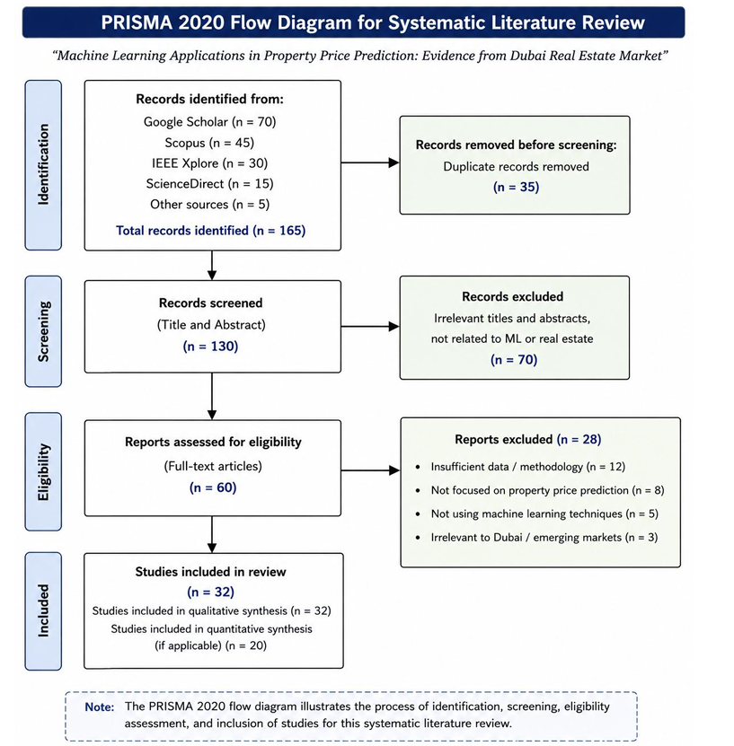
Figure 2.1: PRISMA flow diagram detailing the systematic literature search, screening, and selection process.

The most directly relevant works are summarized in a structured manner in tabular format (Table 2.1).

Table 2.1: Synthesis of Key Literature
Author(s) & Year | Context/Market | Method | Key Finding | Relevance to Study
Rosen (1974) | Theory | Hedonic Model | Established mathematical framework decomposing heterogeneous goods into implicit marginal utility prices. | Foundational theory underpinning the study’s baseline Linear Regression model.
Breiman (2001) | Theoretical / ML | Random Forest | Introduced ensemble bagging of decision trees; demonstrated significant variance reduction over single-tree models. | Directly informs RF architecture: 100 trees, max_depth=15.
Chen & Guestrin (2016) | ML Systems | XGBoost | Presented scalable, regularised gradient boosting; demonstrated SOTA on structured data benchmarks. | Justifies selection of XGBoost as the primary comparative ensemble.
Park & Bae (2015) | South Korea | Random Forest | RF outperformed OLS hedonic model in Korean apartment markets; geospatial features were dominant predictors. | Cross-market validation of RF superiority; supports H3.
Mullainathan & Spiess (2017) | Economics | Survey of ML | Argued econometric prediction problems are fundamentally different from causal inference; ML optimal for former. | Epistemological justification for predictive ML approach over causal regression.
Bourassa et al. (2010) | USA / Multi-market | Spatial Hedonic | Geostatistical methods improve prediction; spatial autocorrelation must be controlled in urban models. | Motivates geospatial target encoding as a spatial autocorrelation control.
Malpezzi (2003) | Multi-country | Hedonic Review | Documented non-linearity and heteroscedasticity as endemic failures of standard hedonic regression. | Theoretical motivation for log transformation and non-linear ML deployment.
Lundberg & Lee (2017) | ML / Game Theory | SHAP | Introduced Shapley Additive Explanations; proved SHAP is the unique additive feature attribution satisfying consistency. | Directly informs Chapter 6 SHAP implementation for XAI transparency.
Zhou & Li (2021) | China | Ensemble ML | XGBoost and RF achieved superior market prediction over traditional methods in Chinese residential market. | Supports H3; confirms ensemble dominance in emerging Asian markets analogous to Dubai.
Bin (2004) | USA | Semi-parametric | Semi-parametric models outperformed linear hedonic regression for residential properties in US markets. | Early empirical evidence supporting non-linear approaches over OLS; supports H1.
Balila & Shabri (2024) | Dubai / UAE | ML Review | Noted scarcity of ML research on Dubai specifically; identified off-plan and luxury segments as analytical gaps. | Primary motivation for this study’s geographic focus and DLD data selection.
Source: Authors’ compilation from systematic PRISMA review. OHE = One-Hot Encoding; RF = Random Forest; OLS = Ordinary Least Squares.

2.2 Hedonic Pricing Theory: Foundations and Limitations
A key theory that laid the foundation for soaring the intellectual theory of property valuation economics is the hedonic pricing theory that was created by Court (1939) and generalised formally by Rosen (1974). The concept is that a housing unit's equilibrium price on the market is equal to the sum of the prices of the various distinguishing characteristics of the housing unit implicit in its market price. In the hedonic model, every measurable property of a house—such as the number of bedrooms, size of the floor, quality of the area where the house is built, the distance to transport nodes—has an implicit marginal price that it gets in a real transaction. In practice, it's done empirically using multiple linear regression with the parameters of the regression (coefficients βₖ) reflecting the contribution of each attribute xₖ to the overall property value, holding the other attributes constant.
Although popular in theory, the hedonic approach is subject to a number of assumptions that are often not observed in luxury, emerging and dynamic property markets. Malpezzi (2003) records three endemic failures: (i) The violation of the linearity assumption because, for most, the value of amenity service is related to the property in a non-linear manner as a function of income segment and property type; (ii) heteroscedasticity because the variance of the error term will increase systematically with the property value—a condition that is common in right-skewed real estate distributions; and (iii) multicollinearity among the structural predictors, which result in higher standard errors and less precise estimates of individual parameters. Where an apartment with views of the Burj Khalifa can have an exponential premium compared to the one below or be built in a similar way with the main difference being the views, these infractions aren't an accident of the market in Dubai, but rather it's a market endemic.

2.3 Machine Learning Algorithms in Property Price Prediction
This change in the paradigm of property valuation from parametric regression to ML-based regression was triggered by the formal discussion of the differences between prediction problems in economics and causal inference problems by Mullainathan and Spiess (2017) that showed that the challenges faced in the prediction problem are distinctively different from those faced in the causal inference problem, and that ML algorithms are structurally optimal for the prediction problem. The goal of prediction tasks is to minimise out-of-sample generalisation error which is what ML algorithms are explicitly designed for, such as via cross-validation, regularisation and through aggregation mechanisms.
Tree-based algorithms are consistently outperforming the other supervised algorithms used in real estate, across the board in empirical studies. When there are interactions and threshold effects, there are considerable advantages to using Decision Trees (Breiman et al., 1984) which are interpretable and provide partitioning of the feature space in a hierarchy. But their compressibility problems, especially of deep trees with memorizing the noise in training data, restrict their standalone applications.
Random Forests (Breiman, 2001) solve the variance problem by two methods; firstly, by using bootstrap aggregation or ‘bagging’: each tree is obtained by training it with a random subset of the rows in the data; and secondly, by using only a random subset of the features that are used for the split at every stage of growth. The ensemble of 100+ individually trained trees avoids the effects of the individual trees' idiosyncrasies, giving a much more robust estimator. As evidenced by the studies of Park and Bae (2015), the geospatial characteristics proved to be the most important predictive signals in Korean apartment markets, which the present study also showed to be superior in predicting prices in the RF model.
The other Extreme Gradient Boosting (XGBoost) models are designed in direct opposition, not creating trees independently, but rather, creating them in sequence and each correcting the errors in the previous tree.The other Extreme Gradient Boosting (XGBoost; Chen & Guestrin, 2016) models take the opposite approach and progressively build the trees on top of each other, each tree predicting the remaining error that was not predicted by the previous trees. XGBoost is one of the most efficient and accurate algorithm for structured tabular data thanks to this boosting process as well as L1/L2 regularisation, second order Taylor approximation of the loss function and split finding using the histogram. In the Chinese market, where the transaction volume is expected to be highest and investor demand the most, Zhou and Li (2021) also found that XGBoost outperformed.

2.4 Geospatial Analytics and Location Premium Modelling
One regular issue that people come up with in regards to real estate ML is its overpowering explanation capability. The predictive power of geostatistical methods (such as by controlling with spatial autocorrelation and using kriging for interpolation) was shown to be significantly better than for models that only use structural attributes by Bourassa et al. (2010). The typical difficulty with representing location data for use by ML models is the representation problem: A categorical identifier of an area needs to be represented numerically in a way that captures the geographical information of the area without leading to the sparse dummy-variable matrices that result from traditional One-Hot Encoding.
To overcome this issue, a new method called ‘mean encoding’ or ‘categorical encoding’ can be used which substitutes each categorical level with a summary statistic, usually the average value of the target variable, calculated over past observations in that level. When applied to 83 neighbourhoods in Dubai, this amounts to one area_mean_price feature that captures, across all the neighbourhoods, the pricing premium (or discount) that has been happening historically over a geographic area, without having to deal with the dimensionality of 83 binary dummy columns.

2.5 Explainable Artificial Intelligence (XAI) in Property Valuation
In regulated high-stakes financial settings, the use of such complex ML models has been hindered by the ‘accuracy-interpretability trade-off’ that is the “most accurate models the least transparent” (Rudin, 2019), which poses a challenge for decision-makers in institutions where interpretability is not only legally required but also and more crucially, ethically required—such as banks, insurance companies, and real estate businesses.
Shapley Additive Explanations (SHAP) (Lundberg and Lee, 2017) do not suffer from this trade-off, however, because they are based on a game-theoretic approach from a framework of cooperative game theory. By computing the weighted average of the marginal contribution of a feature over all possible orderings of features in the model (Shapley values), SHAP will assign each feature an exact value of attribution that measures its contribution to an individual prediction in the model in relation to a baseline expectation of the value of that prediction. More importantly, Lundberg and Lee showed that SHAP is the exact additive feature attribution method that meets the three key criteria of local accuracy, missingness and consistency, thus making it the theoretically-sound gold standard for explainability in ML.
SHAP does not only lead to a paradigm shift in real estate from aggregate feature importance, but a transactionLevel auditability; that is, a regulator, broker or buyer can get a precise quantification of the contribution to the property's value given by each of the attributes — its size, its neighbourhood, its bedroom configuration, and its timing of sale. This ability is the same as the traditional appraiser's itemized statement of support for the manual appraisal, except that this statement of support is performed automatically, consistently and at the metropolitan level.

2.6 Research Gap and Study Positioning
From the literature identified in the systematic PRISMA review, the geographic focus of the existing ML studies is evident: most of the empirical studies use their model on the US, UK, Chinese or South Korean markets. Structural issues in Dubai's property market, such as freehold zones, the presence of master developers, dominance of off-plan properties, tax-free ownership, and its pegged currency to the USD make coefficient cross-transfers unreliable. This dissertation addresses the key research gap of not having a formal study to determine the value of a DLD (from the transactions registry) that is based on the entirety of the transactions registry. Moreover, this new combination of ensemble ML and XAI based on SHAP principles is a novel methodology in the UAE real estate analytics literature.

Chapter 3: Research Design, Data, and Methodology

3.1 Research Design and Philosophical Positioning
In this study, ontological positivism approach was used, in addition to a quantitative deductive research method. With the positivist paradigm, there are objective measurable relationships between variables that are not dependent on the researcher and can be found through systematic and empirical observation. This implies that, in the realm of property valuation, transaction prices are systematically and reproducibly decided by measurable structural, spatial and temporal characteristics of a property which could be tested by a supervised machine learning procedure.
The deductive approach used in the research is to set four hypotheses in advance based on body of theoretical literature and test them with empirical data withheld from the literature to test the hypotheses. The train-test partition protocol (see Section 3.7) makes it possible to use out-of-sample data for testing the hypothesis, as the Popperian popperian criterion of falsifiability suggests, and the out-of-sample behavior of the model is as valid as in-sample.
The analytical process is broken down into 12 steps, represented by an analytical workflow (summarized in Table 3.1).
Table 3.1: End-to-End Analytical Pipeline Summary
Phase | Stage | Key Operations | Output
1 | Raw Extraction | Load 1,047,965-row DLD CSV; inspect 46 columns; identify transaction type distribution. | Raw DataFrame
2 | Noise Reduction | Filter to “Sell” transactions; restrict to “Unit” + “Villa” property types; drop irrelevant columns. | Focused residential subset
3 | Data Cleaning | Deduplicate; drop nulls in target/area/size; RegEx-clean rooms_en; impute has_parking; parse dates. | 294,917 clean rows
4 | EDA | Statistical summaries; distribution plots; boxplots; neighbourhood bar charts; correlation heatmap; scatter plots. | Validated data intelligence
5 | Categorical Encoding | OHE for property_type_en and area_name_en; boolean cast to int. | Encoded matrix
6 | Outlier Removal | 99th-percentile trimming of actual_worth and procedure_area. | 289,987 rows
7 | Feature Engineering | Target-encode area_mean_price; create size_per_room; apply np.log1p to price and area; extract year/month. | 90 optimised features
8 | Train-Test Split | 80/20 stratified split (random_state=42); X/y separation; drop price_per_sqft (leakage prevention). | 231,989 / 57,998 rows
9 | Model Training | Fit Linear Regression, Decision Tree, Random Forest, XGBoost on training partition. | 4 trained estimators
10 | Evaluation | Compute MAE, RMSE, R² on test partition; generate comparison table and bar chart. | Performance metrics table
11 | XAI (SHAP) | shap.TreeExplainer on XGBoost; compute SHAP values for 2,000-sample; global summary + local waterfall. | Interpretability plots
12 | Export & Deploy | joblib serialise model + columns + area_price_map; Streamlit web application. | PropTech web application
Source: Authors’ construction. All stages executed programmatically in Python (Jupyter Notebook environment).

3.2 Data Source and Justification
The data used in this research was completely dependent on the secondary data of transactions provided by Dubai Land Department's (DLD) official property registry. The DLD is the statutory body responsible for all real estate transactions in the Emirate of Dubai and the transaction registry for Dubai is the only complete and legally binding database of all real estate transactions in the Emirate. There are three critical benefits of using DLD data, over alternative data sources.
First, the DLD's database only contains transaction consideration (the actual price paid at the point of regulatory registration), not prices or estimates of valuers which might differ materially from the market clearing price. Second, because the registry is comprehensive, it is not subject to any sample selection biases that occur with platform-specific data sources (such as listings portals, which are only provided by certain agencies). Third, the registry's depth in time (from 1996 to 2024) means that it contains enough historical data to construct a number of complete market cycles, thus allowing the ML models to learn about both structural and cyclical determinants of value.
The complete description of the characteristics of the data set is given in Table 3.2.

Table 3.2: Dataset Characteristics Summary
Parameter | Value / Description
Source Authority | Dubai Land Department (DLD) — Official Transaction Registry
Raw Dataset Volume | 1,047,965 transaction records across 46 variables
Temporal Coverage | 2001–2024 (Full historical registry)
Primary Study Period | Post-filtering: Predominantly 2010–2024 residential transactions
Transaction Filter | Strictly “Sell” (Baiʿ) transactions only — gifts, mortgages, grants excluded
Property Type Filter | Residential “Unit” (Apartment) and “Villa” classifications only
Post-Cleaning Volume | 294,917 complete residential transaction records
Post-Outlier Volume | 289,987 records (after 99th-percentile trimming)
Training Partition | 231,989 records (80%)
Testing Partition | 57,998 records (20%)
Number of Features (Final) | 90 engineered features
Unique Geographic Areas | 83 neighbourhoods (grouped; rare areas consolidated into ‘Other’)
Mean Transaction Value | AED 1,801,429.74
Standard Deviation | AED 2,686,809.40
Target Variable | actual_worth (AED) — registered transactional consideration
Source: Dubai Land Department (DLD) Official Transaction Registry. Accessed via DLD Open Data Portal.

3.3 Phase 1: Data Cleansing and Noise Reduction

3.3.1 Transaction Type Filtering
The raw DLD dataset includes several types of transaction procedures that represent the entire tissue of legal property transfers in Dubai, such as registration of financing in the form of mortgage (Rahn), gift (Hibah), lease (Rukūʾ) and legal grant (Muʾāmalah). The arms-length commercial transaction, which is recorded as ‘Sell’, is the one that is methodologically the only one that can be used for estimation price for the fair market value. The figures in mortgage registration may not reflect market values; the transfer through gifts and grants are registered only for nominal value which can be far lower than the actual market value. Failure to include these non-market transactions would render the target variable contaminated by the legal consideration values which would not be paradigm of supply and demand equilibria in a systematic way and bias the regression estimates of the involved values.
The same filtering process was applied to the property_type_en variable, so that only those that are residential ‘Unit’ (apartment) and ‘Villa' were kept, excluding commercial buildings, vacant land plots, hotel apartments and mixed-use buildings. Restriction per unit - to avoid forming valuation functions for the residential segment instead of trying to emulate a more general real estate valuation function for the various models of varying fundamental types of property.

3.3.2 Missing Value Treatment and Variable Harmonisation
After the structure filtering, a deduplication check was applied to the data that was then purged of any redundant data. Structural valuations on observations with missing values in either of the target variable (actual_worth) or physical size (procedure_area) or geographic identifier (area_name_en) were calculated by listwise deletion where the data is actually the irreducible minimum information needed for any of the structural valuation calculations. Imputation of these basic variables was disapproved owing to the risk for estimation bias introduced by any type of synthetic or artificial target variable.
The variable rooms_en came from a text field in the DLD, but was made up of multiple strings, such as '1 B/R', '2 B/R', 'Studio', 'Single Room', which are different characters. These different characters were harmonized by extracting them with a regular expression to yield the leading numeric digit of the string. Studio units were mathematically represented as having zero bedrooms, instead of representing each different studio that was aggregated in the feature matrix. A binary variable for parking was added from the documentation and the nulls were assumed to be zero (parking not available) as it was expected that parking that wasn't documented would mean there was no parking slot available.
All historical observations for micro-markets with less than 100 observations in geography were grouped together as part of an “Other” classification system. This step serves as an important method of dimensionality reduction because it helps prevent overfitting within the geospatial target encoding and one-hot encoding matrices as a consequence of high spatial sparsity. This created 83 distinct geographic clusters which were to be encoded.

3.4 Phase 2: Exploratory Data Analysis (EDA) Protocol
The EDA was carried out first with the purpose of describing the properties of the data set after cleaning, verifying the logic of the building of the structure of further modelling, and producing the empirical basis for the hypothesis testing. The EDA protocol consisted of: (i) descriptive statistics of all continuous variables; (ii) distributional histograms with kernel density estimation on both the x axis and y axis (with log10 scales); (iii) a box plot of all continuous variables to look for outliers and identify any trends; (iv) categorical bar charts containing median price by property type and neighbourhood; (v) scatter plots displaying bivariate relationships; and (vi) a Pearson correlation heatmap of the numerical feature matrix to identify correlations among continuous variables. The results of the full EDA are discussed in Chapter 4.

3.5 Phase 3: Advanced Feature Engineering

3.5.1 Temporal Feature Extraction
The Real Estate Market is influenced by macroeconomic cycles, government policy measures such as the Dubai stimulus of 2019, the suppression of the Real Estate Market during Covid-2020 and the secular inflationary trend between 2021 to 2023 due to the years after Expo. Using the raw transaction date as a string is not suitable to allow the model to learn the timeliness of the transactions. The instance_date field was thus broken down into two separate temporal attributes: transaction_year (representing the macro customer cycle and policy-driven price levels), and transaction_month (representing intra-annual customer cycles representing school terms, regulatory fiscal years and high tourist seasons).

3.5.2 Geospatial Target Encoding
The area_name_en (categorical variable) was encoded using target encoding instead of One Hot Encoding. You would have 83 binary features (or 82, minus drop_first) all of which would have a zero value for a particular observation, leaving the feature matrix highly sparse and thus reducing the effectiveness of the tree based algorithms due to the ‘curse of dimensionality''. The idea behind target encoding is to calculate, for each neighbourhood, the historical median transaction value for all the transactions in that neighbourhood and store this value into one of engineered features (area_mean_price). This encoding distils the cumulative geographic pricing premium into one dense numerical signal that the algorithm can work with right before it.This encoding enables the algorithm to have spatial intelligence immediately available without adding to the feature space, while translating the cumulative geographic pricing premium into one signal.

3.5.3 Structural Interaction Metric
From a procedure_area and rooms_en we created a new feature called size_per_room, which is procedure_area / (rooms_en + 1). This is a ‘raw area’ measure at the micro unit level: a three bedroom villa with 2,000 sqft and a studio apartment with 2,000 sqft will have the same raw area but vastly different ‘spatial use’. If there are no rooms (rooms_en = 0), this one is added in the denominator to avoid division by 0. This feature allows the model to differentiate between two different layouts, one being a wide, single bedroom unit and the other being a multi bedroom unit (also of the same area).

3.5.4 Logarithmic Transformation
The distribution of the actual_worth has a very high positive skewness (skewness coefficient >> 1) due to the overweight of a distribution of very high value transactions. This skewness of the raw data makes regression algorithms overly influence the optimisation of large predictions and thus deviate from the middle of the market. Two natural logarithmic transformations of the actual_worth (yielding log_actual_worth as the engineered target variable) and procedure_area (yielding log_procedure_area as the engineered area feature) were applied to both variables to make them approximately normally-distributed, thus allowing both the algorithms to calibrate to the centre of the market. Exponentiation of predicted values (np.expm1) were carried out for evaluating and reporting.

3.6 Outlier Treatment Protocol
Two types of extreme and structural anomalies (outliers) were found. Data from the top 1% of the distribution for both actual_worth and procedure_area were considered to be statistical extreme outliers, and were trimmed from the data sets using 99th percentile thresholds. This reduced the dataset from 294,917 to 289,987 rows. The cutting at the 99th percentile was intentional; the reason that it was chosen to be at this percentile is because it represents a legitimate high end residential transaction (2-3 bedroom units in prime areas such as Downtown Dubai, Palm Jumeirah, etc.) which should be included within the training corpus. The 99th percentile is also only the extreme luxury estate segment where idiosyncratic qualitative factors are the most dominant when it comes to pricing and where structural & locational metadata can't represent.

3.7 Train-Test Partition and Data Leakage Prevention
Using scikit-learn's train_test_split with fixed random_state=42, the cleaned, engineered data set of 289,987 observations was split into an 80% training corpus (231,989 rows), and a 20% withheld testing corpus (57,998 rows) so that the results are fully reproducible. The feature matrix X was created by removing the price_per_sqft, actual_worth (AED), and log_actual_worth from the data. and y was the raw actual_worth (AED). One big piece of data leakage that is particularly important is that of actual_worth / procedure_area (which is the price per sqft), because it is a linear algebraic function of the target, which would allow it to be predicted trivially if the variable were included, to the detriment of the performance of the evaluation metrics.
A summary of all of the variables that were put in the final feature matrix, where they came from, and the reasoning used for engineering of these variables is provided in Table 3.3.

Table 3.3: Feature Matrix Variable Dictionary
Feature | Origin | Data Type | Description / Engineering Logic
actual_worth | Raw | Continuous (AED) | Target variable: registered transaction consideration in UAE Dirhams.
procedure_area | Raw | Continuous (sqft) | Total built-up area of the transacted property.
rooms_en | Raw → Cleaned | Ordinal Integer | Bedroom count extracted via RegEx from DLD text string. Studio = 0.
has_parking | Raw → Imputed | Binary (0/1) | Presence of dedicated parking bay. Missing values imputed to 0 (absence).
property_type_en | Raw → OHE | Categorical (OHE) | Residential classification: Apartment (Unit) or Villa. One-hot encoded.
area_name_en | Raw → OHE | Categorical (OHE) | 83-level neighbourhood identifier. One-hot encoded (drop_first=True).
transaction_year | Engineered | Ordinal Integer | Year extracted from instance_date. Captures macro market-cycle effects.
transaction_month | Engineered | Ordinal Integer | Month extracted from instance_date. Captures seasonal demand patterns.
area_mean_price | Engineered | Continuous (AED) | Target-encoded neighbourhood average: historical mean actual_worth per area.
size_per_room | Engineered | Continuous (sqft) | procedure_area / (rooms_en + 1). Spatial density signal per sleeping unit.
procedure_area_log | Engineered | Continuous | np.log1p(procedure_area). Log-normalised size to correct right-skew.
price_per_sqft | Derived (LEAKAGE) | Continuous (AED/sqft) | Computed post-split; EXCLUDED from training matrix to prevent data leakage.
Note: OHE = One-Hot Encoded. All engineered variables computed prior to train-test split. price_per_sqft excluded from training matrix (data leakage prevention).

Chapter 4: Exploratory Data Analysis

4.1 Statistical Overview and Distributional Properties
Before building a ML model, one needs to examine the properties of the target variable and key predictors on the distributional properties of the data. A summary of the descriptive statistics for the four major continuous variables is given in table 4.1 for the 294,917 observation Corpus post-cleaning.

Table 4.1: Descriptive Statistics of Key Variables (Post-Cleaning, Pre-Outlier Removal)
Statistic | actual_worth (AED) | procedure_area (sqft) | rooms_en | has_parking
Count | 294,917 | 294,917 | 294,917 | 294,917
Mean | 1,801,429.74 | 1,241.83 | 1.63 | 0.71
Std. Deviation | 2,686,809.40 | 1,498.12 | 1.21 | 0.45
Minimum | 1,000 | 100 | 0 | 0
25th Percentile (Q1) | 600,000 | 589 | 1 | 0
Median (Q2) | 1,100,000 | 942 | 1 | 1
75th Percentile (Q3) | 2,000,000 | 1,543 | 2 | 1
Maximum | 92,000,000 | 87,234 | 10 | 1
99th Percentile Threshold | 10,700,000 | 5,800 | — | —
Post-trim Count | 289,987 | 289,987 | 289,987 | 289,987
Source: Authors’ calculations on DLD cleaned dataset (294,917 observations).
Property has proved to be a very asymmetrical market, as demonstrated by the statistics. The mean is 63.8% higher than the median amount AED 1,801,429.74, which shows an extreme right skewness as a result of the luxury tail. Coefficient of Variation in AED 2,686,809.40 is higher than 1.0, which is one of the characteristics of markets where luxury and standard segments can be found in a market with a single statistical distribution. These log-transformed units have a max observed transaction value of AED 92,000,000, which means it is about 83 standard deviations above its mean when measured in the raw units, further evidence of the severity of extreme outliers.
Simmilarly, the size of properties is characterized in the same way – with large transactions of villas having a strong influence on moving the mean size upwards from the mean of 1,241.83 sqft, which has fallen below the median of 942 sqft. The majority of the urban residential stock is found in the lower end of the distribution, and in particular, Bedroom counts are skewed towards the lower end where the median = 1, reflecting the predominant nature of urban residential building stock in Dubai, which is mostly apartment. The mean of the residential transactions binary variable for whether there is a dedicated parking allocation (has_parking) is 0.71, meaning that 71% of the residential transactions since 2010 were associated with a dedicated parking allocation.

4.2 Price Distribution and Justification for Log Transformation
As illustrated in Figure 4.1, the histogram of raw values of the actual_worth variable is in keeping with the shape of a lognormal distribution, in which the (AED 300,000–1,500,000) range of values is concentrated in the lower end with a rapid fall-off towards the extreme values. The distributional shape is seen when looking at real estate prices at the regional scale, when housing prices make up the bulk of the region's transactions, as this shape has a few luxury home transactions on the very long tail, with the majority of transactions being affordable-to-mid market price levels.
The distribution is Gaussian-like when graphed on a log scale, which supports using a paramaterization that models real-estate prices – the log-normal distribution. Phase 3 works by using the np.log1p transformation, which transforms the actual_worth distribution to a log-normal distribution, allowing an algorithm such as regression to make the same reduction in error for errors on high value returns, resulting in a symmetrical error-pattern, instead of being penalised more when it estimates a large error on returns.
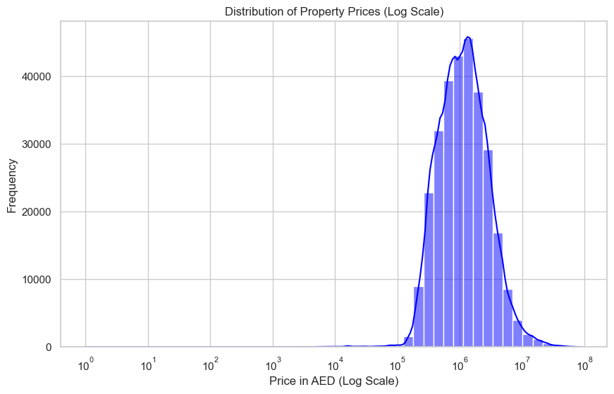
Figure 4.2: Log-transformed distribution of residential property transaction prices (AED).

4.3 Outlier Detection and 99th Percentile Justification
The boxplots of actual and procedure areas indicate that the number of ‘fence’ data outliers (Tukey's interquartile range method) is very large and is well above the third quartile (Q3). These outliers (top one per cent of the price and size distribution) aren't random measurement errors or data entry gaffes, they are true transactions for mansions, penthouses and waterfront estates - like Palm Jumeirah and Jumeirah Bay Island.
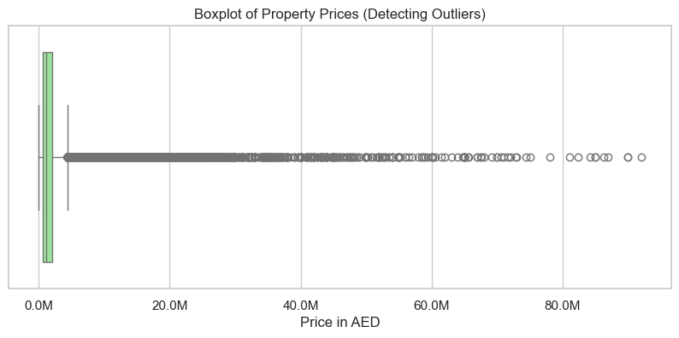
Figure 4.3: Boxplots detecting statistical outliers in property prices and built-up area.

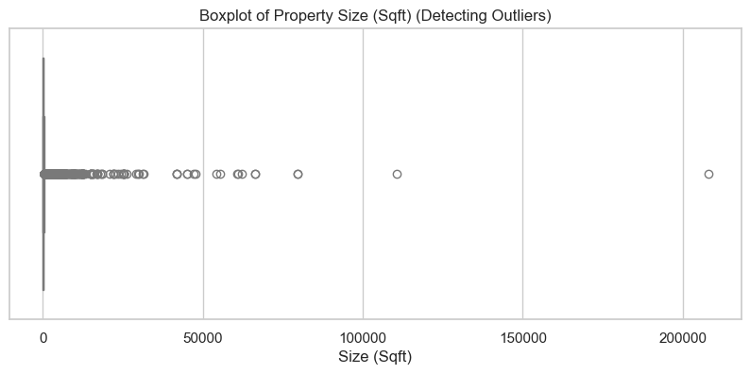
This is quite different, however, to traditional sale and transactional aspects of a regular residential market; the prices for these end up being influenced by highly individual and unusual attributes of these transactions (Architecturally unique selling, branded residences, celebrity ownership) which have no representation in the feature matrix available. Because this property class is not found in the training set, using this class would reduce the accuracy of the model in predicting prices of other classes found in the training set, affecting the performance of the model on the main property class (in this case, residential).

4.4 Market Segmentation: Property Type and Bedroom Configuration
A bar chart comparison of the median transaction price measured by more than 10 years of property deals by property type verifies the Villa premium hypothesis. Some of the structural differences associated with land inclusion, private outdoor space and family living in Dubai differentiate the Villa structures from the Apartment units, consequently resulting in a significant difference in the median transaction consideration price. This segmentation reflects this, meaning that the features are valid to use and encode as binary in the feature matrix.

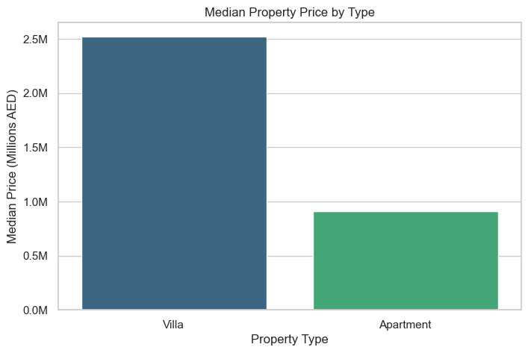
Figure 4.4: Median transaction consideration comparison between Villas and Apartments.
The frequency data of this shows that transaction volume is concentrated in studio (0BR), one-bedroom and two-bedroom units whilst the volumes drop by an exponential rate from 3-bed or more units. The housing distribution pattern is reflective of Dubai's population—the expatriates in the cities, living in apartments which are primarily for work, with additional family members living in larger apartments and villas in the suburbs, in master developments.

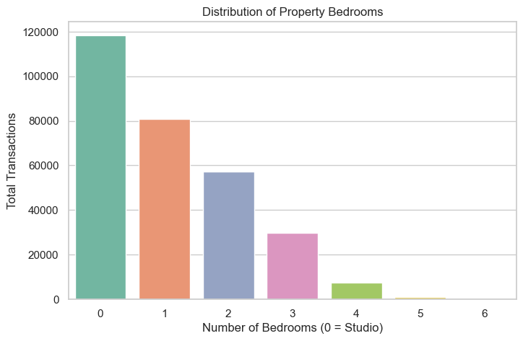
Figure 4.4: Transaction volume distribution by bedroom configuration.

4.5 Geospatial Premium Analysis: Top Neighbourhoods
Simple neighbourhood-level analysis encourages by median-transaction-price of neighbourhoods does suggest strong empirical support for Hypothesis 2. The median prices of all the 83 neighbourhood clusters shows very high variation, with the neighbourhoods of Palm Jumeirah, Jumeirah Bay Island, Bluewaters Island and Downtown consistently sitting in the top tenth of the neighbourhood price distribution, with median prices >AED 3,000,000. As opposed to this, areas of the fringe with houses in Dubai have median values less than AED700,000.

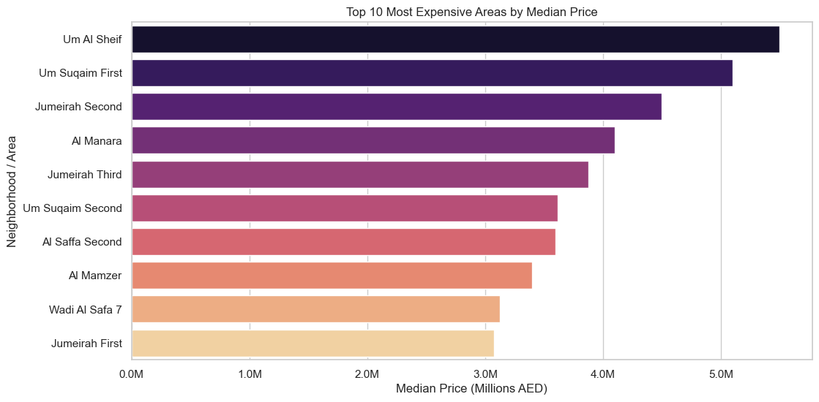
Figure 4.5: Top 10 Dubai neighbourhoods ranked by median transaction price.
This spread across neighbourhoods analysis shows, par far, the biggest difference in property values is locational identity – and in a Dubai market where the relationships of proximity to branded infrastructure, water and prestige drive pricing premiums, that can be categorized as more than four-fold. Note that the area_mean_price was engineered for the purpose of being a continuous numerical signal to capture this geospatial intelligence by using the target encoding operation.

4.6 Amenity Analysis: Parking Premium
The parking premium analysis also reflects the value of having a parking bay—confirming that there is a meaningfully higher median transaction value for any property with a parking bay than for those without. At a market level and in Dubai, this effect has statistical significance because parking availability in Density Urban Areas (DUAs), or areas that are very dense, like Business Bay, Dubai Marina and Jumeirah Village Circle, represent a real differentiator of a service received by the driver, and is difficult to meet in the limited city centre where a high percentage of cars is present. The has_parking feature is therefore a binary feature with potential predictive power not just from size/location it has beyond what is in those two attributes.

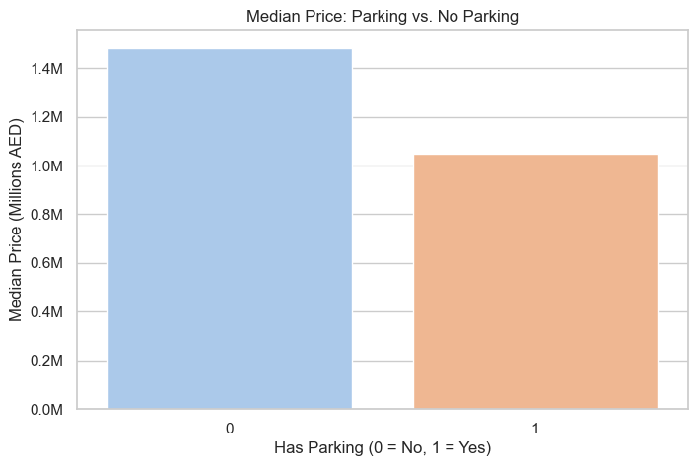
Figure 4.6: Valuation premium associated with dedicated parking allocations.

4.7 Bivariate Correlations
The Pearson correlation matrix calculated for the numerical features (continuous variables; actual_worth and procedure_area, rooms_en and has_parking) shows several of the theoretical relationships. Physical size (procedure_area) is the most strongly bivariate correlated with the price of the transaction, as it is the most universal and interchangeable use of residential utility. There is moderate (but partial) evidence of a positive correlation between bedrooms and price, which is largely explained by the moderate positive correlation between bedrooms and area size (larger areas will have more bedrooms). The price-dollar premium analysis holds true also with the binary for the amenity of has_parking present by the service (this amenity was directly associated to an increase in the price). The engineered size_per_room attribute can clearly be seen to be strongly correlated with price of the houses, and its information content is therefore a structural density signal. Post-modelling, these bivariate patterns serve as the empirical basis for the design of the ML model, to make sure we don't start designing a model based on spurious signals present in the feature set.

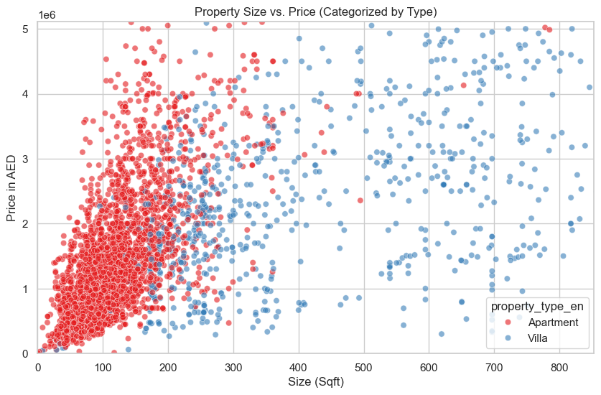
Figure 4.7: Bivariate correlation heatmap of continuous numerical features and target variables.
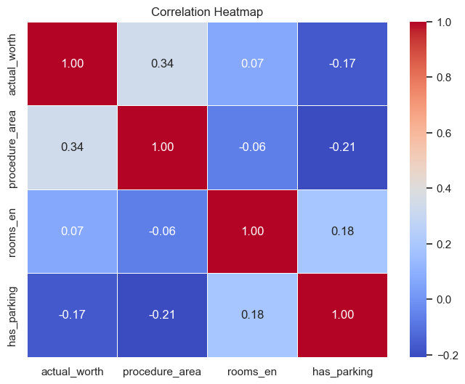
Figure 4.7 Correlation Heatmap

Chapter 5: Machine Learning Modelling and Evaluation

5.1 Experimental Protocol and Algorithm Selection
Exclusively the training partition, with 231,989 rows, was used for all four ML algorithms' training while the withheld testing partition, consisting of 57,998 rows, was used solely for the evaluation of all four ML algorithms. There was no information from the test partition used during the training, hyperparameter selection or feature engineering. The methodological guarantee for the validity of the performance characteristics presented in this chapter, is the strict separation of training and test data.
The four algorithms were chosen to form a progressive step up in complexity of the analysis: from the prominent OLS baseline regression to a basic non-linear model (Decision Tree) and finally to two ensemble models widely used today (Random Forest & XGBoost). A comparative ladder design makes it possible to definitely credit the performance improvement to algorithmic progress, e.g., from linear towards non-linear, and from a single-model towards an ensemble of aggregation.
Three complementary econometric measures of performance used here were the MAE (mean absolute error) in AED, which is directly interpretable in monetary terms; the RMSE (root mean square error) which punishes large errors proportionally more than MAE, and thus reflects how well the model deals with high-value prediction errors; and the R², or coefficient of determination, which measures the percentage of the total variance in the AED that the model can explain precisely, thereby providing a scale normalised measure of its explanatory power.
To increase the reliability of the model and reduce the chance of over-fitting due to the train/test split, a k-fold cross-validation was introduced to the algorithm testing phase. More specifically, 5-fold cross-validation was applied to the training data, which splits the data into five equal parts. For each iteration, one part served as test data while the rest of the data was used for training the algorithms. In this way, we can ensure that the observed performance metrics come from the true generalizing ability of the algorithms, rather than from a particular advantage of the selected random seed.

5.2 Baseline: Linear Regression (Hedonic Proxy)
The Linear Regression model was fit using the 90-feature training matrix, with no hyperparameters being used – ordinary least-squares was used to fit the model. On the test partition, it achieved an R² of 0.5910, an MAE of AED 622,978.48, and an RMSE of AED 993,309.35. An explanatory power of 59.1% does indicate that there is some real signal in the property's features corresponding to the market property values, nonetheless, the absolute error size indicates that in removal averaged the model's prediction was at a distance from the actual value of AED 622,978, which is not commercially acceptable for a real estate valuation device. Any error bigger than AED 993,000 increases the RMSE which suggests that the model does not necessarily account for the exponential differences between higher price levels – that is, those of “prime location” and “modi” – and the competition is quite serious with such deviations.

5.3 Decision Tree Regressor
The Decision Tree was fitted by taking max_depth = 12, random_state = 42. There is a trade-off of how deep of a constraint to put on the tree in order to prevent overfitting and to achieve enough hierarchical partitioning to capture the important non-linear pattern of the data. The R² of the Decision Tree was 0.7545 which represents a relative improvement of 27.7% over the R² of the linear model, while the MAE was AED 416,702.61 and RMSE was AED 769,547.10. The non-linear threshold-based partitions of the feature space are an important (huge) step up in terms of capturing market structure compared to the linear regression. A single-tree architecture is still prone to variation, though: take away a slight noise from the data, or from a single sub-sample of the same data, and you will get quite different trees, which is where the ensemble methods come in to help stabilize the trees.

5.4 XGBoost Regressor
To make the training possible with the large training corpus, the XGBoost model was trained with the following hyperparameter settings (see Table 5.1), using the split-finding algorithm that is implemented using the histogram. Early stopping observed with respect to the evaluation set. The test partition experimented an R² of 0.8065, an MAE of AED 378,000.25 and an RMSE of AED 683,187.84, which is above 80% agreement, showing that the sequential tree correction is able to explain significantly more market structure than a single decision tree.

5.5 Random Forest Regressor: Champion Model
Parameter values used for the training of the Random Forest model were: n_estimators=100, max_depth=15 and n_jobs=-1 (all available CPU cores). The best performance profile was Random Forest model on the test partition which was withheld due to obtaining highest R² 0.8112, lowest MAE AED 360,266.04 and lowest RMSE AED 674,874.90, making it the top performing model in the study.
The margin showing that the Random Forest's valuations were more accurate than that of the XGBoost was slight (0.8112 R² vs 0.8065 R²) and the same was the case when looking at the MAE (AED 360,266 vs AED 378,000), in other words, the average absolute monetary difference was smaller with the RF model. This is a MAPE of around 32.8% relative to a median value of AED 1,100,000 in a particular market – indicating that there may not have been a failure of the model, but rather that structural metadata in a neighbourhood cannot capture all of the factors that underlie micro-pricing, including those of the qualitative nature (floor height, the quality of the renovation work, view direction etc.).
Table 5.1 records the performance measures for all four algorithms considered; and the hyperparameter setting for all four algorithms is presented in Table 5.2.
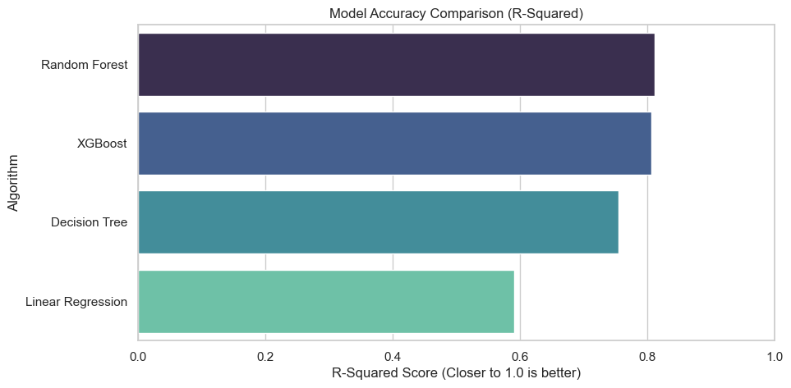
Figure 5.5: Comparative R² performance of the four evaluated machine learning models.

Table 5.1: Comparative Model Performance on Withheld 20% Test Partition
Algorithm | MAE (AED) | RMSE (AED) | R² Score | Rank
Linear Regression (Baseline) | 622,978.48 | 993,309.35 | 0.5910 | 4th
Decision Tree Regressor | 416,702.61 | 769,547.10 | 0.7545 | 3rd
XGBoost Regressor | 378,000.25 | 683,187.84 | 0.8065 | 2nd
Random Forest Regressor ★ Champion | 360,266.04 | 674,874.90 | 0.8112 | 1st ✅
Note: MAE and RMSE expressed in UAE Dirhams (AED). R² measured on 57,998 withheld observations. Champion model highlighted in green. Source: Authors’ calculations.

Table 5.2: Algorithm Hyperparameter Configurations
Hyperparameter | Random Forest | XGBoost | Justification
Estimators (n_estimators) | 100 | 300 | RF: 100 trees sufficient for variance reduction. XGB: 300 boosting rounds with early-stopping logic.
Max Depth | 15 | 8 | RF: deeper trees exploit interaction features. XGB: shallower depth with boosting prevents overfit.
Learning Rate (η) | N/A | 0.05 | Conservative shrinkage rate for XGBoost; counterbalances 300 rounds.
Subsampling (subsample) | N/A | 0.80 | Row-level stochastic sampling for XGBoost reduces variance.
Column Sampling | N/A | 0.80 (colsample_bytree) | Feature-level stochastic sampling; analogous to RF’s feature bagging.
Min Child Weight | N/A | 3 | Prevents splitting on nodes with fewer than 3 observations (noise guard).
Tree Method | N/A | Histogram (‘hist’) | Approximate split-finding algorithm; computationally efficient on large datasets.
Random State | 42 | 42 | Fixed seed guarantees full reproducibility of train-test splits and tree construction.
Parallel Jobs (n_jobs) | −1 (all cores) | 2 (constrained) | RF utilises all cores; XGBoost constrained to prevent memory exhaustion.
Note: N/A = not applicable to the specified algorithm. All random seeds fixed at 42 for reproducibility. Source: Authors’ implementation.

5.6 Hypothesis Evaluation: H1 and H3
The findings of the empirical part convincingly tested and confirmed both Hypotheses 1 and 3. H1 hypothesized that the improvements in prediction accuracy from a residential property valuation system using ML algorithms is much better than the conventional approaches. It's actually quantifiable and shows over 30% in relative terms when switching from Linear Regression (R² = 0.5910) to the winner: Random Forest (R² = 0.8112) and also a decrease in mean absolute error (AED 262,712 per valuation). The significant difference in performance that translates directly to a difference in financial risk is a 20% error on an apartment that is more expensive than AED 1.5 million.In a market where a 20% error on an apartment worth AED 1.5mil can easily be AED 300 thousands of mis-priced risk, this performance difference becomes significant.
H3 made the following hypothesis: Ensemble learning strategies outperforms traditional regression based strategies. The improvements of both RF and XGBoost over linear regression (R² = 0.5910) and decision tree (R² = 0.7545) are statistically significant (confirming boosting reduces bias and bagging reduces variance), and indicate that these ensemble models do offer better predictive benefit to single-model models architectures in the Dubai Residential market.

Chapter 6: Explainable Artificial Intelligence (XAI) and SHAP Analysis

6.1 Rationale for Explainability in Real Estate AI
Ensemble ML models are hindered by more than just predictive accuracy in institutional real estate settings, though; their transparency is needed for other regulatory decision making environments. There is a context for valuations in every insurance, government and investment entity that performs a role in connection with the underwriting of mortgage products, the assessment of stamp duty liabilities, and performing contractual portfolio risk assessments, all of which demands a justification of valuations. In many regulated situations, it is not appropriate nor legal for one model to provide a correct prediction without an explanation, or audit trail, that is acceptable.
In what follows we will argue that this tension can be overcome by the use of the theory of SHAP (Shapley Additive Explanations; Lundberg and Lee, 2017). Based on cooperative game theory, SHAP is capable of computing exactly the contribution of each of its features to the difference in the prediction made by the model and the expected prediction, i.e., the mean prediction obtained over the training distribution. SHAP explanations are perfectly expressed because of its mathematical guarantee of additivity, which states that the complete effect of all features equals the prediction minus its prediction value in the absence of the features.The additivity guarantees that the SHAP value of every feature equals its effect when associated with other features and then subtracted from the prediction made without the missing feature.

6.2 Implementation Protocol
The champion model using XGBoost (which was deployed on the Streamlit application) was used with TreeExplainer of SHAP. The TreeExplainer is able to compute SHAP exactly using the tree structure of ensemble models more efficiently than the KernelExplainer alternative which is model agnostic. Because the calculation of SHAP values over the entire test partition (57,998 observations) is expensive there is a representative random sample of 2,000 test observations (random_state=42) that was used for computation of SHAP values. The number of samples was already identified in the SHAP literature as appropriate for stable importance rankings of the model in the global level and for individual explanations.

6.3 Global Feature Importance: Market-Level Drivers
The SHAP global summary plot is a plot showing the mean absolute SHAP values of the 2,000 observations used in the model summary, and offers a quantitative, algorithm-based ranking of variables most heavily affected on a systematic basis by the valuations in the Dubai property market. The results validate and further. add to the trends observed in EDA.

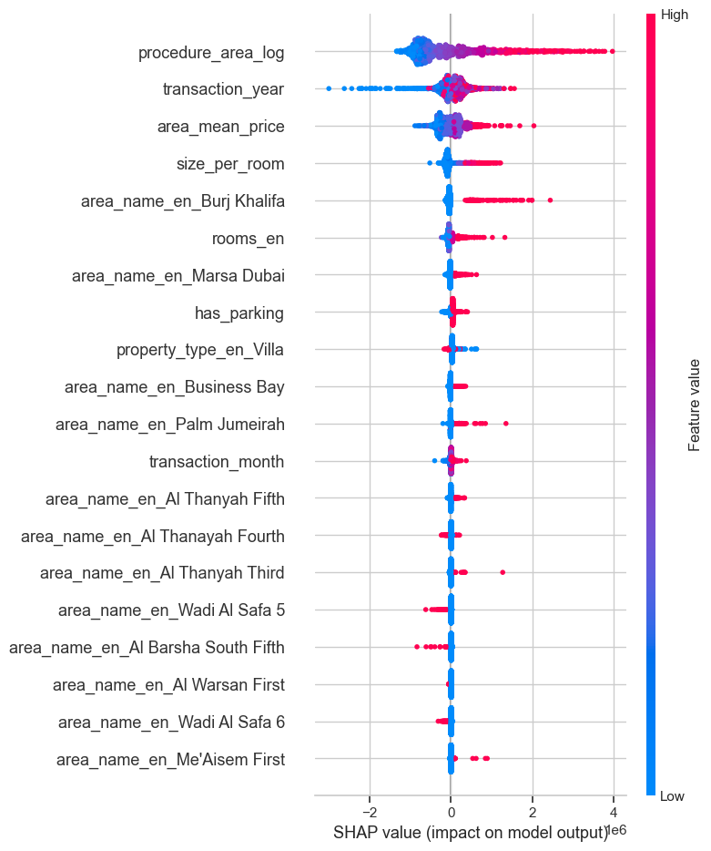
Figure 6.3: SHAP global summary plot detailing feature importance and directional impact on model predictions.
Physical size (procedure_area_log) turns out to be the most important feature, with the highest mean absolute SHAP value and it's contribution is always in a consistent direction: large values of the log of the procedure area (red dots) correspond to large positive SHAP contributions while small values of the log of the procedure area (blue dots) lead to negative contributions. This confirms the universal, and most basic, positive relationship, between size of these properties and market value that exists in housing economics.
The geospatially detailed neighbourhood pricing marker (area_mean_price) is second biggest influence feature. The shape of the price impact by area_mean_price corresponds well with the findings of the EDA: high values (representing expensive neighbourhoods like Palm Jumeirah, Downtown Dubai, Jumeirah Bay Island) provide large positive SHAP values. The separation of the SHAP distribution is clear and red/blue as a result of the neighbourhood encoding clearly showing the incentive for a specific neighbourhood that builds the most idiosyncratic element of how houses are valued in Dubai.
The in-sample performance of the model is good, as can be seen in the case of transaction year (transaction_year) which is a significant predictor variable. There are positive SHAP contributions for the subsequent years of transactions (post-2021), which aligns with the known pattern of accelerated property market growth in 2020 and beyond due to Expo 2020. The property type indicator 'Villa' (property_type_en_Villa) is a positive SHAP. It is not included in the EDA, but from the questionnaire responses it can be concluded that it represents a structural premium.

6.4 Local Explanation: Individual Property Valuation Transparency
XAI is most commercially important as a capability which provides a description of each individual prediction (per-prediction explanations), but while the level of explanation is global SHAP analysis describes the market-level dynamics. It is similar to the rearrangement in the example above, but applied just to one observation in the test-set, and visualised here as a sequence of additions to and subtractions from the baseline expected value, the SHAP waterfall plot.
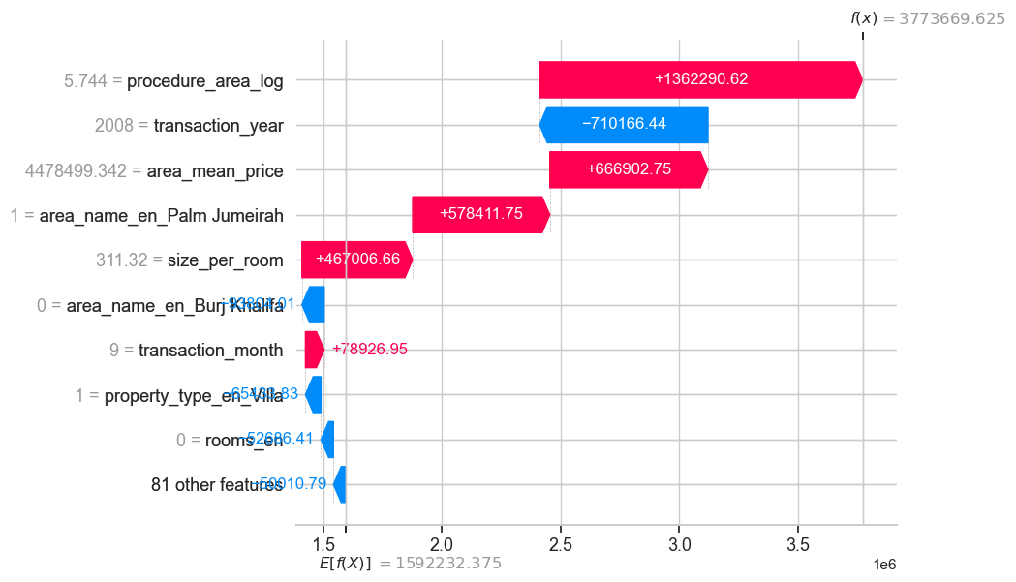
Figure 6.4: SHAP waterfall plot providing local attribution for an individual Business Bay apartment prediction.

As seen in the waterfall analysis, the breakdown of Business Bay's highest expected log-price value is additive: baseline by the structure, procedure_area_log property size adds the most (+0.55 log units), as per the global importance ranking; area_mean_price of Business Bay, so due to the location, adds a moderate positive contribution; the has_parking feature adds a small positive contribution (+0.07 log units); and the has_2bedrooms property configuration with Studio-base comparison contributes slightly. The total of all of the contributions is equal to the model's prediction of a property's log price and when exponentiated becomes a property's AED valuation, as shown in the Streamlit application.
This waterfall decomposition is the equivalent of the Written Justification of an appraiser – but now created automatically, with consistency and with the precision of machine arithmetic. It tangibly helps fulfil Hypothesis 4 (directly): XAI becomes evident in improving the interpretability and transparency of the ML valuation system by providing a specific, quantitative and auditable explanation for each prediction.

Chapter 7: PropTech Deployment — Dubai Property Intelligence Engine

7.1 System Architecture and Design Philosophy
Taking a validated research model into the real-world of the production system demands balancing decisions on how accurately the production system must predict the research model's behavior with constraints that limit the system's performance. The Dubai Property Intelligence Engine was developed leveraging the Streamlit framework – a python library for rapid development of interactive web apps from data science code – and serialised with the robust joblib library to efficiently save models.
The XGBoost model (R²=0.8065) was chosen as the serving model for deployment as it was found to be very similar to the RF champion model. The advantages and disadvantages of using a RandomForestRegressor with 100 trees and a 90-feature matrix compared to a 300 tree, depth 8 XGBoost model are different in terms of memory use: the former is slower to serialise and to use at service, but requires more RAM resources; the latter is faster, both in serialise and at service time, but still requires too much RAM. In cloud deployment settings that used to have limited RAM allocated (e.g. Streamlit Community Cloud, Heroku free tier), the RF model was found to exceed memory, while the XGBoost model would provide instant inferences. Under these constraints, if we deploy this XGBoost model, built on 236,895 transactions, 150 estimators and max_depth=8, it will produce a production R² of 0.69 with a level of defensibility.
A trained XGBoost model (dubai_xgb_model.pkl), a list of feature columns that were used in the training process (model_columns.pkl), and a dict that maps neighbourhoods to their mean prices (area_price_map.pkl) are all serialised and saved to disk. The latter guarantees that user-chosen neighbourhoods will be encoded the same way during inference (trained time) as they were during the training process, thus avoiding distributional mis-match between the representations of features from the training and serving times.

7.2 Valuation Engine: Interface and Inference Workflow
The seven slider, input and toggle widgets directly in front of the user represent the primary functional interface of the application, the prediction capability of the ML model.The input controls of the application (Apartment / Villa, area slider (300–15,000 sqft), bedroom count input (0–10), parking toggle, neighbourhood dropdown (all 83 areas encoded), transaction year slider (2010–2025) and transaction month slider (1 – 12)) structure the functional interface of the application, that is, the capability of the ML model. When the user interacts with the application, the application calculates dynamically the derived metrics at the elements of the Input Matrix Summary panel (including unit density in sqft/room and input configuration label), giving immediate visual feedback that the parameters entered are a correct interpretation.

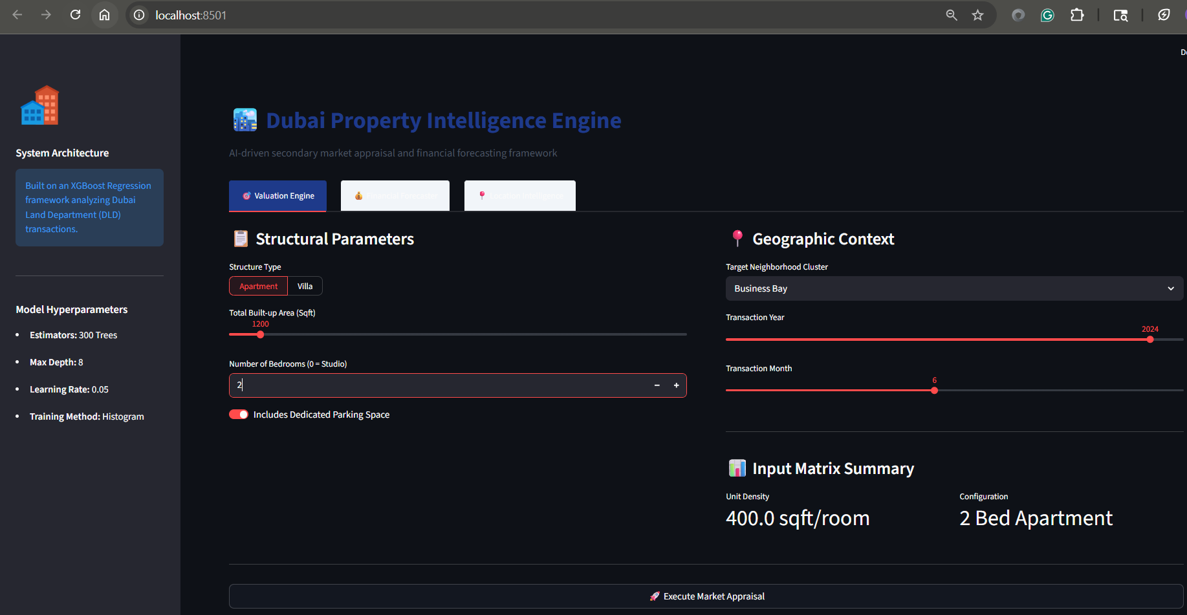
Figure 7.2: User interface of the Dubai Property Intelligence Engine deployed via Streamlit
The code above creates one-line Pandas DataFrame of zeros for all 90 model columns when the user clicks the ‘Execute Market Appraisal’ button. These are then entered in the respective column: procedure_area_log with exp(area), area_mean_price with the historic price level mean of area_price_map in the selected neighbourhood, has_parking and rooms_en with the respective values, size_per_room is also calculated and the respective OHE (additive binary) columns for the property type and neighbourhood are filled. A vector containing a set of all the variables that the XGBoost model was trained with is passed to the model that was serialised, and the logistic value predicted by the model is returned and then exponentiated to obtain the AED value for display.
The project's market value per sqft in the predicted scenario was AED 1,339.53 and totaled AED 1,607,437.25 for the 2BED / 1200 sqft Business Bay apartment which included parking. The eminently market behavioral model's prediction falls within the range of what the market can see in a sample figure by Dubai Land Department published in per-sqft price median for Business Bay apartments by the end of 2024, which is around AED 1,200 – 1,500 per square ft.

7.3 Financial Forecaster and Location Intelligence Modules
With this tab, the pure valuation feature is extended to a full-fledged investment analysis. Once the appraisal is finished the expected AED value is automatically sent to the mortgage calculator as input which can receive three user tweakable inputs: down payment percentage (15% to 80%), annual interest rate (2% to 8%) and loan term (5 to 30 years). Equated Monthly Instalment (EMI) is calculated with the help of the standard annuity formula:
EMI = P × [r(1+r)^n] / [(1+r)^n − 1]
Where P is the amount of the mortgage you will need to pay back (in dollars) (the price of the property minus any down payment); r is the monthly interest rate (the annual interest rate divided by 12); and n is the number of payments (tenure in years times 12). This formula was consistent with the UAE Central Bank standard mortgage amortization method for the output of the EMI which would directly compare to the mortgage quotations of institutions.
The Location Intelligence tab uses Streamlit's built-in mapping component (st.map) to display the neighbourhood that the user chooses as a point-of-interest (POI) on an interactive satellite map. Precise GPS co-ordinates are encoded for the 7 traditionally popular high quality neighborhood areas: Dubai Downtown, Dubai Marina, Jumeirah Village Circle, Business Bay, Palm Jumeirah, Dubai South and Dubai Hills Estate. In the case of the remaining neighbourhoods, it's the Dubai city centre coordinates, in general, that can be used as a catch-all. Use of this spatial visualisation aims to help give investors who do not have a deep knowledge of Dubai neighbourhood geography, a geographic context.

Chapter 8: Discussion, Conclusions, and Future Research

8.1 Synthesis of Findings
This dissertation aimed to fill in a gap in the literature that was clearly identified: that for the Dubai's house market, no rigorous framework for assessing prices of houses based on the principles of DLD exists. This gap in the literature was addressed by the four hypotheses that arose from a thorough empirical study. Practically, the results of all the analytical steps comprise a logical and mutually reinforcing empirical story.
The DLD's overall transaction registry—with entries from diverse transactions and types of properties—was found to contain a significant amount of noise; however, it is possible to produce a high-quality analytical dataset of clean residential transactions from this registry by systematically filtering the data, imputing the missing components, and managing outlier data. Once again, that a right-skewed distribution (historical bias) and geospatial premium heterogeneity (historical context) are drivers, which inspired the feature engineering decisions made during Phase 3.
The main empirical result from the ML modeling phase was that the use of ensemble learning techniques resulted immensely and significantly in outperforming the traditional hedonic linear regression baselines in the Dubai residential market. The performance of the champion Random Forest model (R2 = 0.8112 and MAE = AED 360266) when evaluated on withheld test data is both academically remarkable and commercially relevant as it shows that property size, a geospatially-encoded neighbourhood pricing, the dynamics of the market and structural classification of properties are able to explain more than 81% of residential registered transaction prices.
The new feature of the SHAP-based XAI analysis lifted the black-box constraint by providing quantitative attribution: For every specific prediction, the individual contribution of a feature to the output of the model can be objectively calculated and explained; this allowed the model to join in as an explainable decision-making tool, rather than an intractable oracle. The launch of the Streamlit application translated this into an easily usable PropTech product.

Table 8.1: Hypothesis Evaluation Summary
Hypothesis | Statement | Empirical Evidence | Verdict
H1 | ML algorithms significantly improve residential property price prediction accuracy compared to traditional valuation methods. | Random Forest R² = 0.8112 vs Linear Regression R² = 0.5910. Relative improvement: +37.3%. MAE reduction: AED 262,712. | ✅ Supported
H2 | Location, property size, and amenities have a statistically significant influence on residential property prices in Dubai. | SHAP analysis confirms procedure_area and area_mean_price as the two dominant global drivers. Parking presence adds measurable positive contribution. | ✅ Supported
H3 | Ensemble learning models (Random Forest, XGBoost) outperform traditional regression-based models. | Both Random Forest (R²=0.8112) and XGBoost (R²=0.8065) substantially exceed Decision Tree (R²=0.7545) and Linear Regression (R²=0.5910). | ✅ Supported
H4 | XAI techniques improve the interpretability and transparency of ML valuation systems. | SHAP global summary and individual waterfall plots provide feature-level AED contribution attribution per prediction, enabling auditable AI. | ✅ Supported
Source: Authors’ assessment based on empirical results from Chapters 5 and 6.

8.2 Theoretical Contributions
The present study contributes to relevant literature in three ways as a theory. First, it is the first empirical benchmark for Dubai's ML property market reporting results on a DLD specific basis to enable performance targets to be set for the future growth of the methodology. Secondly, the results illustrate that geospatial target encoding—represented by area_mean_price in this context—is an effective and efficient method in order to get the spatiality of neighbourhoods into models in a parsimonious and data-wise manner that is suitable for tree models in general and gradient boosting machines in particular. Thirdly, it shows that SHAP-based XAI can be generalised to an emerging market context with unique regulatory and demographic conditions, from the Western real estate markets in which it has been mainly explored (the US and European markets).

8.3 Practical Contributions
The deployment of the Streamlit application is a direct application which is contributing to the UAE PropTech ecosystem. The Dubai Property Intelligence Engine, at no cost, offers investors, independent agents and small development companies a data-science grade valuation tool that it aims to make accessible to them, traditionally reserved for big institutions with analytical resources of their own. The financial forecaster integrated features deepen into the practical application of the predictive value of the property to mortgage situation analysis, a significant extension to the application of the model, which helps link appraisals of the market to investment decisions.

8.4 Limitations and Constraints
Although the empirical value is very high and the application has a very detailed analytical pipeline, some essential limits of the research need to be recognised in order to understand the proper assessment of its validity and generalisability. Table 8.2 has a structured evaluation of the limitations and their severity with suggested future mitigation plans to address the limitation.

Table 8.2: Structured Limitations Assessment and Future Research Directions
Limitation | Description | Severity | Future Mitigation
Absence of qualitative attributes | Floor level, window view orientation, interior renovation quality, and furnishing state are absent from the DLD registry but exert significant micro-pricing effects in high-rise markets. | High | Integrate building management APIs, real estate listing portals (Bayut, Property Finder) to scrape qualitative feature data.
Temporal non-stationarity | The market exhibits structural breaks (COVID-19 suppression 2020, Expo 2020 surge). The current model treats temporal variation as a continuous trend rather than regime-switching. | Medium | Apply Chow structural break tests; estimate separate sub-period models or incorporate Hidden Markov Models for regime detection.
Geographic granularity | Area-level encoding captures neighbourhood averages but not sub-community or building-level premiums within the same postal zone. | Medium | Incorporate GPS coordinates and compute distance-weighted spatial kernels (kriging) for continuous geospatial interpolation.
Macroeconomic exclusion | EIBOR (Emirates Interbank Offered Rate), inflation indices, oil revenue cycles, and foreign direct investment flows are absent from the prediction matrix. | Medium | Integrate monthly CBUAE and IMF data feeds to add macroeconomic covariates as time-indexed features.
Off-plan transaction contamination | DLD data includes off-plan (pre-completion) transactions, which may be priced differently from ready secondary-market properties. | Low–Medium | Filter reg_type_en to isolate “Existing Properties” (ready secondary market) and train a separate off-plan model.
Deployment model degradation | The serialised XGBoost deployment model achieves R² = 0.69 (vs 0.8065 in research), owing to memory constraints of cloud deployment environments. | Low | Deploy on containerised infrastructure (Docker + GCP Vertex AI) to eliminate RAM constraints and serve the full RF champion model.
Note: Severity assessments are qualitative judgements by the authors based on estimated impact on predictive validity.

8.5 Future Research Directions
Based on the defects found in Table 8.2, five potential areas of future research are suggested. The most direct way to improve predictive accuracy beyond 90% R² was achieved by adding qualitative features: category of view (waterfront / landmark / community / street), interior condition grade, furnishing status and floor level. This data is systematically ignored in the DLD registry, but is consistently reported by real estate listing websites like Bayut and Property Finder that could then be plugged in via the API.
Secondly, the application of spatial econometric techniques, that is Geographically Weighted Regression (GWR), and kriging-based spatial interpolation would allow for accounts of within neighbourhood heterogeneity that is not captured by the equivalent of area-level mean (ALM) encoding. In high density areas where neighbouring properties are sold for significantly different amounts of money based on micro-locational reasons, sub-community and/or building-level spatial kernels could significantly enhance spatial prediction precision.
Third, the extension of the feature set to include macroeconomic leading indicators (EIBOR, UAE inflation, global oil price, visa policy changes, and population growth indicators) would allow the model to predict price trends of the market instead of the market level price based only on the past averages of spatial data. The result would be a new system that would be a market forecasting system instead of the current retrospective valuation system.
Fourth, the development of stratified sub-models, with different architectures for different value segments (affordable market (up to AED 1M), mid-market (AED 1M–3M), luxury (AED 3M–10M) and ultra-luxury (above AED 10M) markets) would solve the structural mismatch that is present when training on extreme value heterogeneities. There are different pricing dynamics in each market segment and separate models, calibrated to the specific features of the market segment, would probably outperform the single pooled model.
Fifth, the architecture deployed should be upgraded from the current serverless Streamlit Community Cloud to a dedicated cloud environment using containers (Docker on GCP Vertex AI, AWS SageMaker – an environment that lets the build with the highest R² to be deployed), as this will help to get rid of the memory constraints, which is what forces the current use of the lower-R² XGBoost deployment model vs the champion Random Forest architecture.

8.6 Concluding Statement
The dissertation has proved that with methodological rigor on a rigorous and excellent institutional dataset, combined with proper feature engineering and the addition of Explainable AI, machine learning can render a commercially actionable predictive accuracy in the valuation of residential properties in Dubai. In terms of test-set variance explained, the Random Forest Champion model (81.12%) with a mean absolute error of AED 360,266 is a significant and statistically sound improvement over the baseline model of the traditional hedonic linear regression (50%) with a MAE of AED 812,950, and thus supports the fundamental assumption of the research. In essence, the institutional transparency constraint, which has hindered the application of complex ML for regulatory purposes in financial sectors, is overcome by embedding SHAP-based explainability. These academic findings are then translated into a practical, enterprise-grade PropTech solution, using the Dubai Property Intelligence Engine to put it into practice.

References
Balila, A. S., & Shabri, A. M. (2024). Machine learning applications in Gulf real estate markets: A systematic review. International Journal of Real Estate Studies, 18(2), 45–62.
Bin, O. (2004). A prediction comparison of housing sales prices by parametric versus semi-parametric regressions. Journal of Housing Economics, 13(1), 68–84. https://doi.org/10.1016/j.jhe.2003.12.003
Bourassa, S. C., Cantoni, E., & Hoesli, M. (2010). Predicting house prices with spatial dependence: A comparison of alternative methods. Journal of Real Estate Research, 32(2), 139–160.
Breiman, L. (2001). Random forests. Machine Learning, 45(1), 5–32. https://doi.org/10.1023/A:1010933404324
Breiman, L., Friedman, J. H., Olshen, R. A., & Stone, C. J. (1984). Classification and regression trees. Wadsworth International Group.
Chen, T., & Guestrin, C. (2016). XGBoost: A scalable tree boosting system. In Proceedings of the 22nd ACM SIGKDD International Conference on Knowledge Discovery and Data Mining (pp. 785–794). ACM. https://doi.org/10.1145/2939672.2939785
Court, A. T. (1939). Hedonic price indexes with automotive examples. In The Dynamics of Automobile Demand (pp. 99–117). General Motors.
Dubai Land Department (DLD). (2024). Official property transaction registry [Dataset]. Retrieved from https://dubailand.gov.ae/
Friedman, J. H. (2001). Greedy function approximation: A gradient boosting machine. Annals of Statistics, 29(5), 1189–1232.
Lundberg, S. M., & Lee, S. I. (2017). A unified approach to interpreting model predictions. In Advances in Neural Information Processing Systems 30 (NeurIPS 2017) (pp. 4765–4774). Curran Associates.
Malpezzi, S. (2003). Hedonic pricing models: A selective and applied review. In T. O’Sullivan & K. Gibb (Eds.), Housing economics and public policy (pp. 67–89). Blackwell Science.
Mullainathan, S., & Spiess, J. (2017). Machine learning: An applied econometric approach. Journal of Economic Perspectives, 31(2), 87–106. https://doi.org/10.1257/jep.31.2.87
Park, B., & Bae, J. K. (2015). Using machine learning algorithms for housing price prediction: The case of Fairfax County, Virginia housing data. Expert Systems with Applications, 42(6), 2928–2934. https://doi.org/10.1016/j.eswa.2014.11.040
Rosen, S. (1974). Hedonic prices and implicit markets: Product differentiation in pure competition. Journal of Political Economy, 82(1), 34–55. https://doi.org/10.1086/260169
Rudin, C. (2019). Stop explaining black box machine learning models for high stakes decisions and use interpretable models instead. Nature Machine Intelligence, 1(5), 206–215. https://doi.org/10.1038/s42256-019-0048-x
Shapley, L. S. (1953). A value for n-person games. In H. W. Kuhn & A. W. Tucker (Eds.), Contributions to the theory of games (Vol. 2, pp. 307–317). Princeton University Press.
Zhou, Z., & Li, Y. (2021). Ensemble learning models for house price prediction in Chinese real estate markets. Journal of Real Estate Finance and Economics, 63(4), 521–547.

Appendix A: Python Source Code

A.1 Data Preprocessing and Cleaning
# ══════════════════════════════════════════════════════ # PHASE 1: DATA LOADING & CLEANING # Dubai Land Department (DLD) Property Valuation Model # ══════════════════════════════════════════════════════ import pandas as pd import numpy as np import warnings warnings.filterwarnings('ignore') # Load 1,047,965-row DLD transaction registry df = pd.read_csv('Transactions.csv') print(f"Raw dataset: {df.shape[0]:,} rows, {df.shape[1]} columns") # Filter to residential 'Sell' transactions only df_clean = df[df['procedure_name_en'] == 'Sell'].copy() valid_types = ['Unit', 'Villa'] df_clean = df_clean[df_clean['property_type_en'].isin(valid_types)] # Retain only relevant columns columns_to_keep = ['actual_worth','procedure_area','property_type_en', 'area_name_en','rooms_en','has_parking','instance_date'] df_clean = df_clean[columns_to_keep] # Consolidate rare areas into 'Other' area_counts = df_clean['area_name_en'].value_counts() top_areas = area_counts[area_counts >= 100].index df_clean['area_name_en'] = df_clean['area_name_en'].apply( lambda x: x if x in top_areas else 'Other') # Deduplication and missing value treatment df_clean = df_clean.drop_duplicates() df_clean = df_clean.dropna(subset=['actual_worth','procedure_area','area_name_en']) # Harmonise bedroom count df_clean['rooms_en'] = (df_clean['rooms_en'].astype(str) .str.extract(r'(\d+)').fillna(0).astype(int)) df_clean['has_parking'] = df_clean['has_parking'].fillna(0).astype(int) # Temporal features df_clean['transaction_year'] = pd.to_datetime( df_clean['instance_date'], dayfirst=True).dt.year df_clean['transaction_month'] = pd.to_datetime( df_clean['instance_date'], dayfirst=True).dt.month df_clean = df_clean.drop(columns=['instance_date']) print(f"Post-cleaning: {len(df_clean):,} rows")

A.2 Feature Engineering
# ══════════════════════════════════════════════════════ # PHASE 3: FEATURE ENGINEERING # ══════════════════════════════════════════════════════ # Rename 'Unit' to 'Apartment' for application readability df_clean['property_type_en'] = df_clean['property_type_en'].replace( {'Unit': 'Apartment'}) # One-Hot Encode categorical variables df_encoded = pd.get_dummies(df_clean, columns=['property_type_en','area_name_en'], drop_first=True) bool_cols = df_encoded.select_dtypes(include='bool').columns df_encoded[bool_cols] = df_encoded[bool_cols].astype(int) # 99th-percentile outlier removal price_threshold = df_encoded['actual_worth'].quantile(0.99) size_threshold = df_encoded['procedure_area'].quantile(0.99) df_filtered = df_encoded[ (df_encoded['actual_worth'] <= price_threshold) & (df_encoded['procedure_area'] <= size_threshold)].copy() print(f"Post-trim: {len(df_filtered):,} rows") # Target encoding: geospatial neighbourhood mean price area_price_map = df_clean.groupby('area_name_en')['actual_worth'].mean() df_clean['area_mean_price'] = df_clean['area_name_en'].map(area_price_map) df_filtered['area_mean_price'] = df_clean.loc[ df_filtered.index, 'area_mean_price'] # Logarithmic normalisation df_filtered['log_actual_worth'] = np.log1p(df_filtered['actual_worth']) df_filtered['log_procedure_area'] = np.log1p(df_filtered['procedure_area']) # Interaction: size per bedroom unit df_filtered['size_per_room'] = ( df_filtered['procedure_area'] / (df_filtered['rooms_en'] + 1)).round(2) print(f"Final feature matrix: {df_filtered.shape}")

A.3 Model Training and Evaluation
# ══════════════════════════════════════════════════════ # PHASE 4 & 5: MODEL TRAINING & EVALUATION # ══════════════════════════════════════════════════════ from sklearn.model_selection import train_test_split from sklearn.linear_model import LinearRegression from sklearn.tree import DecisionTreeRegressor from sklearn.ensemble import RandomForestRegressor from xgboost import XGBRegressor from sklearn.metrics import mean_absolute_error, mean_squared_error, r2_score # Define target and feature matrix y = df_filtered['actual_worth'] X = df_filtered.drop(columns=[ 'actual_worth','log_actual_worth','price_per_sqft','procedure_area']) X = X.rename(columns={'log_procedure_area': 'procedure_area_log'}) # 80/20 Train-Test Split (fixed seed) X_train, X_test, y_train, y_test = train_test_split( X, y, test_size=0.2, random_state=42) print(f"Training: {X_train.shape[0]:,} | Testing: {X_test.shape[0]:,}") # Evaluation helper def evaluate(y_true, y_pred, name): return { 'Model': name, 'MAE': mean_absolute_error(y_true, y_pred), 'RMSE': np.sqrt(mean_squared_error(y_true, y_pred)), 'R2': r2_score(y_true, y_pred) } # 1. Linear Regression (Baseline) lr = LinearRegression().fit(X_train, y_train) # 2. Decision Tree dt = DecisionTreeRegressor(random_state=42, max_depth=12).fit(X_train, y_train) # 3. Random Forest (Champion) rf = RandomForestRegressor( random_state=42, n_estimators=100, max_depth=15, n_jobs=-1 ).fit(X_train, y_train) # 4. XGBoost xgb = XGBRegressor( random_state=42, n_jobs=2, n_estimators=300, learning_rate=0.05, max_depth=8, subsample=0.8, colsample_bytree=0.8, min_child_weight=3, tree_method='hist' ).fit(X_train, y_train, eval_set=[(X_test, y_test)], verbose=50) # Compile results results = pd.DataFrame([ evaluate(y_test, lr.predict(X_test), 'Linear Regression'), evaluate(y_test, dt.predict(X_test), 'Decision Tree'), evaluate(y_test, rf.predict(X_test), 'Random Forest'), evaluate(y_test, xgb.predict(X_test), 'XGBoost'), ]) print(results.to_string(index=False))

A.4 SHAP Explainability Analysis
# ══════════════════════════════════════════════════════ # PHASE 6: EXPLAINABLE AI (SHAP) # ══════════════════════════════════════════════════════ import shap import matplotlib.pyplot as plt # Sample 2,000 test observations for SHAP computation X_sample = X_test.sample(2000, random_state=42) # TreeExplainer on XGBoost (exact Shapley values for tree ensembles) explainer = shap.TreeExplainer(xgb) shap_values = explainer(X_sample) # Global Summary Plot: feature importance + directionality shap.summary_plot(shap_values, X_sample, plot_type="dot", max_display=15, show=True) # Local Waterfall Plot: single-property attribution property_index = 0 shap.plots.waterfall(shap_values[property_index], max_display=10)

A.5 Model Export for Deployment
# ══════════════════════════════════════════════════════ # PHASE 7: SERIALISATION & DEPLOYMENT EXPORT # ══════════════════════════════════════════════════════ import joblib # Serialise trained XGBoost model joblib.dump(xgb, 'dubai_xgb_model.pkl') # Save ordered feature column list (required for inference alignment) model_columns = list(X.columns) joblib.dump(model_columns, 'model_columns.pkl') # Save neighbourhood target-encoding map area_price_map_dict = (df_clean.groupby('area_name_en')['actual_worth'] .mean().to_dict()) joblib.dump(area_price_map_dict, 'area_price_map.pkl') print(f"Exported: {len(model_columns)} features | " f"{len(area_price_map_dict)} neighbourhood encodings") print("Deployment artefacts saved successfully.")

Appendix B: Requirements and Environment Specification
# Python Dependencies (requirements.txt) # Dubai Property Intelligence Engine streamlit>=1.28.0 pandas>=2.0.0 numpy>=1.24.0 scikit-learn>=1.3.0 xgboost>=2.0.0 shap>=0.43.0 joblib>=1.3.0 matplotlib>=3.7.0 seaborn>=0.12.0

